Inducible conditional knockout: https://getargeting-2026.vercel.app/inducible-conditional-knockout

- Can we space this a bit better, putting some more text on the bottom line:
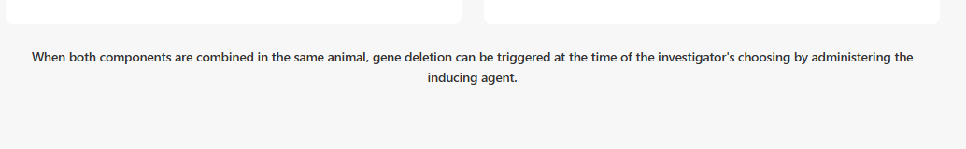

- These publications are correct but again the format is different than other pages on the site. Can we make them more uniform? i.e. In this format, the article title isn’t highlighted in any way:
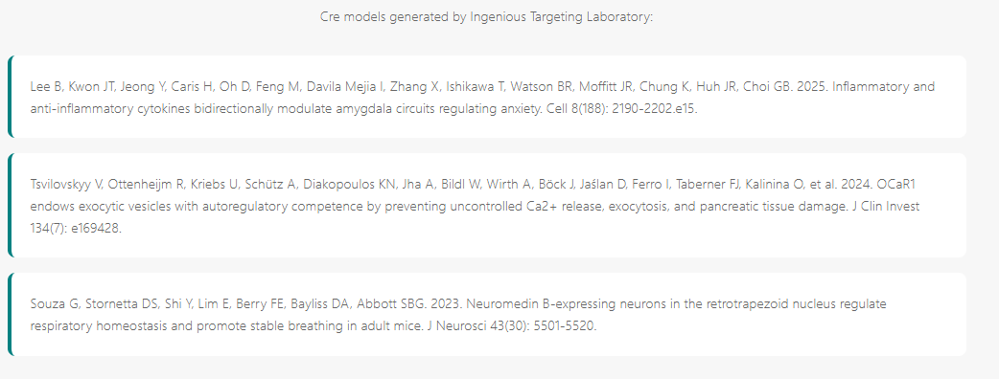

- The first resource is behind a paywall fyi and I’d like to keep it that way. The second we have to vest. With how the AI has been generating images, I’m not confident in its ability to generate an accurate breeding scheme without confirmation from our breeding people:
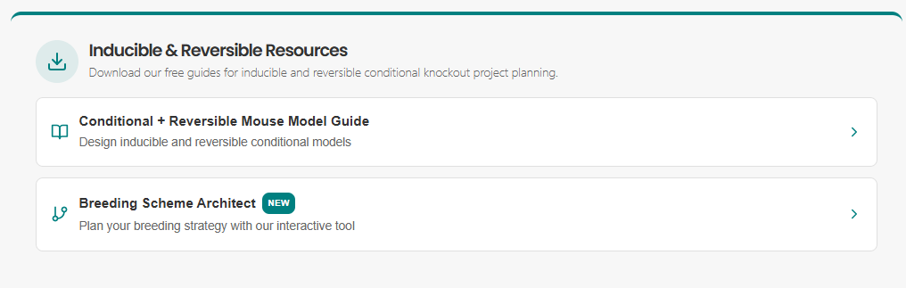

- In the bottom links, please remove the Doxycycline Inducible Systems link and delete this page from the site completely. We cannot say we use this technology:
